**PRACTICAL 4: Functions and Structure**

**AIM:**

To write programs demonstrating functions and structure

**THEORY:**

**Functions:** A function is a subprogram or module to which any amount of data can be sent but which returns only one value. A function is used to perform some logically isolated tasks. it makes it easier to write programs and keep track of what they are doing. It avoids rewriting the same series of instructions over and over. These instructions are written once but are used at several places in the main program as and when desired.

**Types of user defined function:** 1. Function with no argument no return value

2. Function with no argument with return value

3. Function with an argument with no return value

4. Function with an argument with return value

**Q1. Write a C++ program to create a function named as area and find area of triangle using no return and no parameter**

**CODE:**

#include <iostream>

using namespace std;

//function to calculate area of traingle using no return and no parameters

void area_of_triangle()

{

float base, height;

cout << "Enter the base and height of the triangle: ";

cin >> base >> height;

cout << "The area of the triangle is: " << (base * height) / 2 << endl;

}

//main function

int main()

{

area_of_triangle();

}

**OUTPUT:**

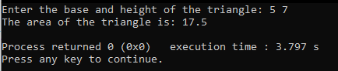

**Fig1. Output of program showing the are of triangle after taking base and height as input**

**Q2. Write a C++ program to create function for adding two numbers with return and with parameter**

**CODE:**

#include <iostream>

using namespace std;

int add(int a, int b)

{

return a + b;

}

int main()

{

int a, b;

cout << "Enter the two numbers to add: ";

cin >> a >> b;

cout << "The sum of the two numbers is: " << add(a, b) << endl;

}

**OUTPUT:**

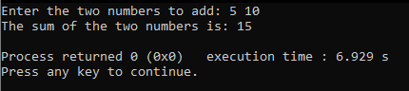

**Fig2. Output of program showing addition of two numbers**